**NOAA Ship THOMAS JEFFERSON Procedure Document**

Procedure:

**Ellipsoidially Referenced Dynamic Draft (ERDDM)**

Creation Date:

8/28/2020

Revision Date:

3/22/2022

Software used:

POSPac, POSPacAutoQC

Procedure Number:

**TBD**

Approved:

**TBD**

# Overview and Scope

# Procedure Inputs and Outputs

## Inputs:

.000

## Outputs:

.xlsx, HVF

# Procedure

**Ellipsoidially Referenced Dynamic Draft Model (ERDDM)**

Take a static draft. If you are unsure of how to take a static draft use SOP "K:\Standard_Operating_Procedures\05_HSRR\2022 - Static Draft.docx". Launch static drafts cannot be done while underway. You must be at a dock to take static measurements on a launch.

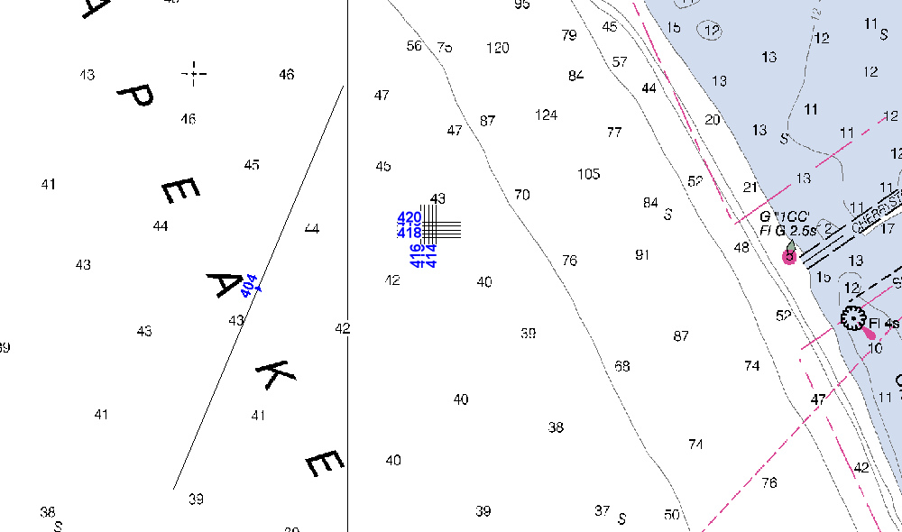

Create a line plan with just 1 line. For ERDDM to work properly you want to run where the Ellipsoid is relatively flat to the earth. At the beginning of the line, start logging while Dead In Water for at least five minutes. Continue the line, increasing speed along the way. In the launches, the RPMs should be adjusted to increase speed by 1.5-2.0 knots (200 rpm). Maintain the same RPM for two minutes and increase again. This should be repeated until the launch is at full ahead, and data has been logged at that speed for at least two minutes.

DIW for 3-5 minutes, and then repeat this procedure, running the line in the reciprocal direction. This is to account for any currents that may be affecting the draft.

After your POS data has been collected, process an SBET as you normally would. The SOP can be found here "K:\Standard_Operating_Procedures\03_Processing\5 - POSPac Processing\2022 - Manual SBET Processing_POSpac8.7.docx".

After your SBET is processed, run it through POSPacAutoQC. The SOP can be found here "K:\Standard_Operating_Procedures\03_Processing\5 - POSPac Processing\2022 - POSPac Auto QC_PydroXL19.docx"

Select the Dynamic Draft tab and use the small scroll bar on the right to scroll to the last set of plots. Click the Save button at the bottom and save the image in the appropriate HSRR folder.

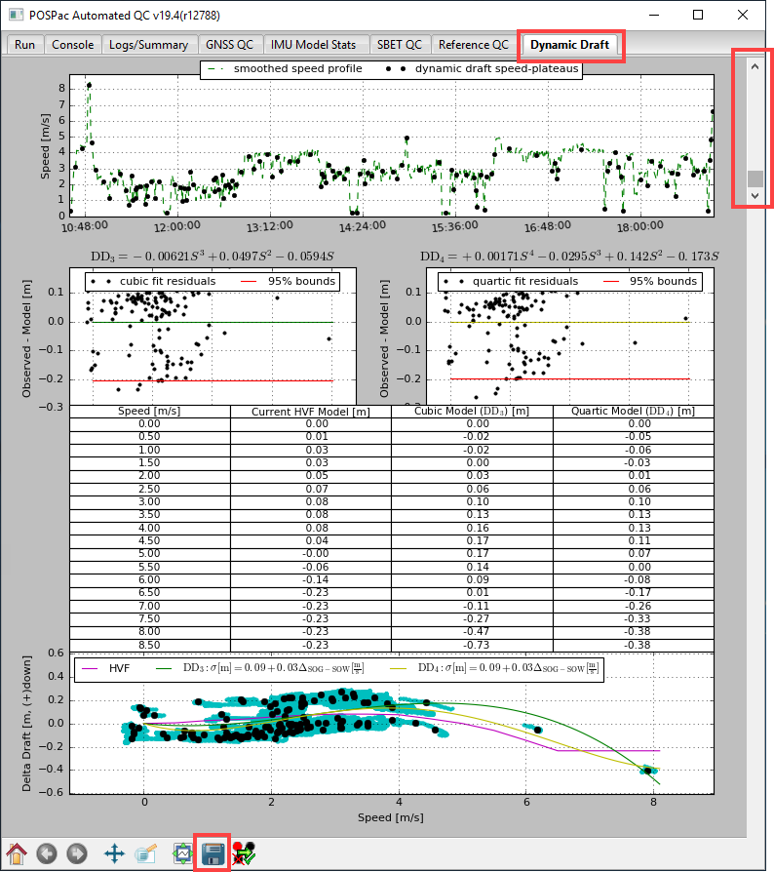

Open up the spread sheet "K:\Standard_Operating_Procedures\05_HSRR\Reference Files\Dynamic_draft_20XX.xlsx”. Use Save As to create a new copy in the current year’s HSRR folder.

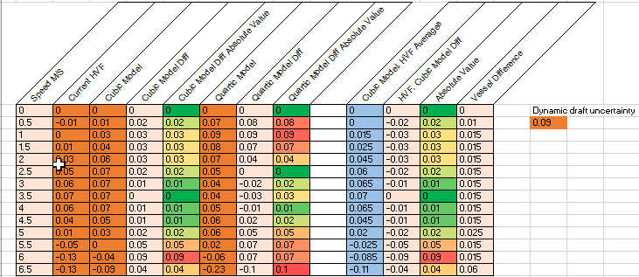

This spread sheet was designed to Average the HVF dynamic draft of the previous year with the cubic model. You should only have to insert values into the orange cells. The light blue cells are the values you are going to insert into the HVF along with the Dynamic daft Uncertainty value.

Using the table that was created by POCPac AutoQC, enter the current HVF dynamic draft values, Cubic model values, and the Quartic Model values within their respective cells in the spreadsheet.

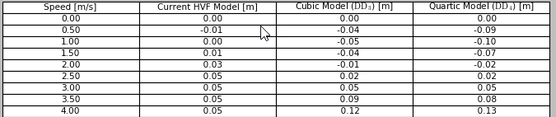

Enter the Dynamic Daft Uncertainty that can be found here within the plot (see image below). This is the uncertainty for the Cubic model “experiment” essentially. You do not want to use the uncertainty of the values themselves for your uncertainty. You want to use the model uncertainty from the plot image.

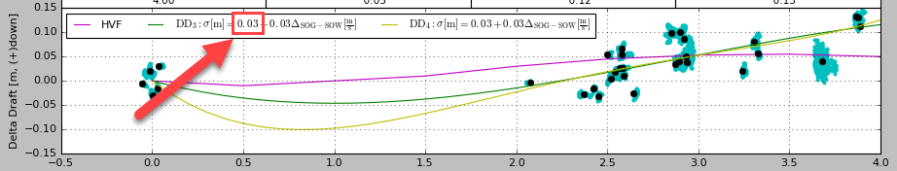

Insert the saved POSPac AutoQC plot into the spreadsheet and save.

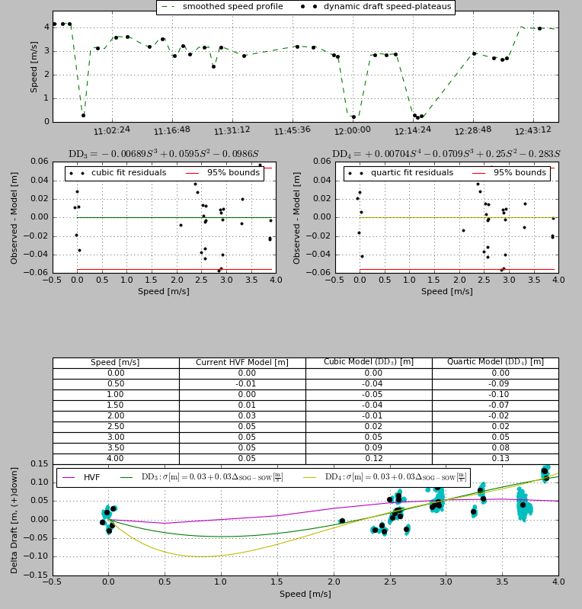

With your spreadsheet filled, out open up the Caris Vessel Editor. Open up the Vessels HVF. Go to the Draft section, set the date to the day the POS data was collected, and click on the meatballs menu under Error.

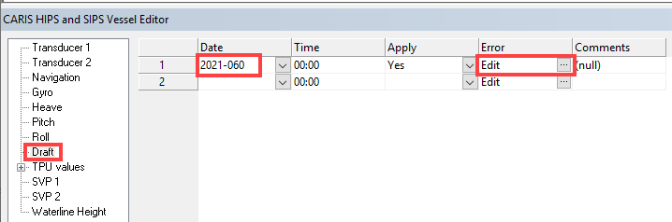

Enter in the draft values for the correct speed within the popup dialog box. The Draft (m) values come from the cells within the spreadsheet that are light blue under “Cubic Model, HVF Averages”. The correlating speed can be found in the table on the left within the spreadsheet.

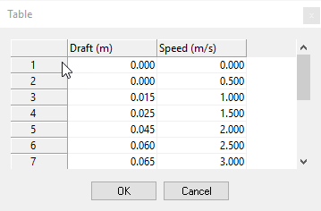

After your values are inserted click okay. Next click the drop down for TPU values. Select the StdDev category. Scroll to the right within the category till you see “Delta Draft (m)”. Insert your Dynamic draft uncertainty value from the spreadsheet under Delta Draft (m) category.

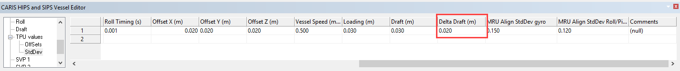

Save your HVF. Do this for each vessel.

# References

"K:\Standard_Operating_Procedures\05_HSRR\2020 - Static Draft.docx"

"K:\Standard_Operating_Procedures\03_Processing\5 - POSPac Processing\2020 - Manual SBET Processing_POSpac8.3.docx".

"K:\Standard_Operating_Procedures\03_Processing\5 - POSPac Processing\2020 - POSPac Auto QC_PydroXL19.docx"

"K:\Standard_Operating_Procedures\05_HSRR\Reference Files\Dynamic_draft_2020.xlsx"